A Project on

**Indian Sign Language Detection**

Submitted by

**SHASHANK KUMAR**

**SOHAM SINGH**

**ANURAG SINGH**

**2021-2022**

Under the guidance of

**Mr. Mithilesh Vishwakarma**

Submitted in partial fulfilment of requirement for qualifying B.Sc.-(Data Science) Semester-V Examination



**Thakur College of Science and Commerce,**

**Thakur Village, Kandivali (E),**

**Mumbai-400101**



**Certificate**

This is to certify that the project titled “**Indian Sign Language detection**”. Undertaken at the “Thakur College of Science and Commerce” by **Mr. Shashank Kumar** Roll No. **3636.** in partial fulfilment of B.Sc. I.T degree Examination had not been submitted for our other examination and does not form part of any other course undergone by the candidate.

___________________________ ___________________________

External Examiner Internal Examiner

___________________________ ___________________________

Project Guide Head of Department



**Certificate**

This is to certify that the project titled “**Indian Sign Language detection**”. Undertaken at the “Thakur College of Science and Commerce” by **Mr. Soham Singh** Roll No. **3615.** in partial fulfilment of B.Sc. I.T degree Examination had not been submitted for our other examination and does not form part of any other course undergone by the candidate.

___________________________ ___________________________

External Examiner Internal Examiner

___________________________ ___________________________

Project Guide Head of Department



**Certificate**

This is to certify that the project titled “**Indian Sign Language detection**”. Undertaken at the “Thakur College of Science and Commerce” by **Mr. Anurag Singh** Roll No. **3609.** in partial fulfilment of B.Sc. I.T degree Examination had not been submitted for our other examination and does not form part of any other course undergone by the candidate.

___________________________ ___________________________

External Examiner Internal Examiner

___________________________ ___________________________

Project Guide Head of Department

**Acknowledgment**

The success and final outcome of this project will require a lot of guidance and assistance from many people and We are extremely fortunate to have got this all along the partial completion of our project work. Whatever we have done is only due to such guidance and assistance and we would not forget to thank them.

We owe our profound gratitude to our project guide **Mr. Mithilesh Vishwakarma** who has taken keen interest in our project **Indian Sign Language detection** and guiding us all along, till the completion of our project work by providing all the necessary information for developing a good system.

We heartily thank our Class -Teacher/HOD **Mr. Omkar Singh**, Department of Data Science, for his guidance and suggestions during this project work.

We are thankful to and fortunate enough to get constant encouragement, support and guidance from all Teaching staffs of Department of Data Science which helped us in successfully completing our initial phase of our project work. Also, We would like to extend our sincere regards to all the non-teaching staff of department of Data Science for their timely support.

Shashank Kumar

Soham Singh

Anurag Singh

INDEX

|  |  |  |  |
| --- | --- | --- | --- |
| Sr  No. |  | Topics | Page No. |
| 1 |  | **INTRODUCTION** |  |
|  | 1.1 | Introduction | 8 |
|  | 1.2 | Objective and Scope of the Project | 9 |
|  | 1.3 | Theoretical Background | 10 |
|  | 1.4 | Problem Definition | 12 |
|  | 1.5 | Software Requirement Specification ( SRS ) | 13 |
|  | 1.6 | Feasibility Study | 15 |
|  | 1.7 | Details of Hardware and Software Used | 17 |
|  |  |  |  |
| 2 |  | **SYSTEM ANALYSIS AND DESIGN** |  |
|  | 2.1 | Detail Life Cycle of the Project | 19 |
|  | 2.2 | Data Flow Diagram | 21 |
|  | 2.3 | Use Case Diagram | 22 |
|  | 2.4 | Activity Diagram | 23 |
|  | 2.5 | Sequence Diagram | 24 |
|  | 2.6 | Component Diagram | 25 |
|  | 2.7 | Architecture Design | 26 |
|  |  |  |  |
| 3 |  | **SYSTEM PLANNING** |  |
|  | 3.1 | Gantt Chart | 28 |
| 4 |  | **Cost And Benefits analysis and Software Parameter Estimation** | 30 |
| 5 |  | **System Testing** | 33 |
|  | 5.1 | Methodology Adopted For Testing | 33 |
|  | 5.2 | Testing Principles | 33 |
|  | 5.3 | Testing Methods | 33 |
|  | 5.4 | White Box Testing | 33 |
|  | 5.5 | Black Box Testing | 34 |
|  | 5.6 | Types of Testing | 34 |
|  | 5.7 | Alpha Testing | 34 |
|  | 5.8 | Beta Testing | 35 |
|  | 5.9 | Performance Testing | 35 |
|  | 5.10 | Recovery Testing | 35 |
|  | 5.11 | Software Testing Strategies Adopted: | 36 |
|  | 5.12 | Unit Testing | 36 |
|  | 5.13 | Integration Testing | 36 |
|  | 5.14 | System Testing | 36 |
|  | 5.15 | Regression Testing | 37 |
| 6 |  | **Implementation** | 38 |
| 7 |  | **Future Work** | 42 |
| 8 |  | **References** | 43 |

* 1. **INTRODUCTION**

Sign language is the medium of communication for the hearing impaired people. It uses gestures instead of sound to convey meaning. It combines hand-shapes, orientation and movement of the hands, arms or body, facial expressions and lip-patterns for conveying messages. It is not universal and just like spoken language, it has regional dialects. American Sign Language (ASL), British Sign Language (BSL), Indian Sign Language (ISL) etc. are some of the common sign languages in the world. In India, over 2 million people are deaf. They find it difficult to communicate with the normal people as the hearing or normal people are unfamiliar of sign language. There arises the need for sign language interpreters who can translate sign language to spoken language and vice versa. But, the availability of such interpreters is limited and expensive. This resulted in the development of automatic sign language recognition systems which could automatically translate the signs into corresponding text or voice without the help of sign language interpreters. Such systems can help in the development of deaf community through human computer interaction.

Sign language recognition is an important research area since there are a lot of challenges in developing an automatic recognition system. Most of the researchers in this area concentrate on the recognition of American Sign Language (ASL) since most of the signs in ASL are single handed and thus, complexity is less. Another attractive feature is that ASL already has a standard database that is available for use. When compared with ASL, Indian Sign Language (ISL) relies on both hands and thus, an ISL recognition system is more complex. The research works carried out by the researchers in the recognition of ISL is very less. Recently, more researchers have started doing research in this area. A project is currently going on at IIT, Guwahati, India which is aimed to develop an automatic ISL education and recognition platform for hearing impaired students of India.

Hand gestures are the largely used traits of computer vision applications. These are getting used from a Hand gestures are the largely used traits of computer vision applications. These are getting used from a very long time for sign based communications. Involvement of computers and concept of digital image processing very long time for sign based communications. Involvement of computers and concept of digital image processing have boosted the activities in the hand gesture modelling and recognition approaches. Sign language is an extended have boosted the activities in the hand gesture modelling and recognition approaches. Sign language is an extended application of hand gestures. In spite being introduced ages ago, standard sign languages are not very common among application of hand gestures. In spite being introduced ages ago, standard sign languages are not very common among peoples in the society. However, from a personal to societal level, hand gestures have made their existence in every peoples in the society. However, from a personal to societal level, hand gestures have made their existence in every domain of life. Gesture controlled wheel chair is one examples of personal level application, where sign languages domain of life. Gesture controlled wheel chair is one examples of personal level application, where sign languages eradicate the communication gap among people that contributes to societal benefits that hand gestures provide. Par- eradicate the communication gap among people that contributes to societal benefits that hand gestures provide. Partially paralyzed people can express their needs via hand gestures. People with autistic challenges face difficulties in associating themselves within community. They uses or could use the hand gestures to communicate. Hand gestures not only emerge as the remedy of personal and societal needs, but also, as an element of luxury. Gesture controlled lights, home automation, 3-D gesture controlled video games like PS4 being perfect examples of the use of hand gestures as an element of luxury. Recently, a famous car manufacturing company BMW has also launched hand gesture control features in their 5*th* series cars, which is going to start the trend of touchless screens. Medical streams use hand gesture controlled 3D-MRI image viewer that would enable the doctors to navigate it during the surgery.

Hand gestures can be modelled using two approaches : Physical sensor based gesture modelling and Computer vision based gesture modelling. Physical sensor based hand gesture modelling uses physical sensors such as flex sensors, accelerometers and gyroscope for accumulating the data. The devices used in conjunction with physical sensors are single board computers such as raspberry pi and Arduinos for processing the data. These devices are not easy to configure and calibrate. Also, devices being fragile needs intense handling care. Computer vision based technique, on the other hand uses camera and algorithm to model the hand gestures. It mitigates human vision system to accumulate and interpret the gestures. Proposals of various fast algorithms, introduction of multiple smaller parallel computational units such as GPUs and availability of large datasets such as Kaggle have paved the path for computer vision approach to be used efficiently for modelling and recognizing hand gestures. Now computer vision based applications used for processing the hand gestures can be run on personal computers too, thereby attracting more researches to be done in this field.

**1.2 OBJECTIVE AND SCOPE OF THE PROJECT**

**OBJECTIVE**

The Objective of Indian sign language recognition system is to provide an efficient and accurate system to convert sign language into text so that communication between deaf and normal people can be more convenient. Because Most of the people cannot communicate with any Deaf person,

Because they do not have any understanding of Sign language everyone knows about sign language but no one actually puts any efforts to learn it. Since Nowadays everyone is communicating through applications such as zoom, google meet, facetime etc. Still we do not have any real time translation for Indian Sign language or any other sign languages.

By this project we are trying to solve this problem and create an application where any deaf or dumb person can communicate via hand gestures.

**SCOPE**

* Indian Sign Language designed for Indian deaf and dumb community.
* The system understands all Signs of English letters from A - Z.
* The system also understands some sign gestures such as hello, bye, thank you etc.
* Translates signs and gestures in real time.
  1. **THEORETICAL BACKGROUND**

**Image Acquisition**

The image acquisition of signer, i.e. the person conveying in the sign language, can be obtained by using a camera. The initiation of the acquisition can be done manually. A camera sensor is needed in order to capture the features/ gestures of the signer.

**Pre-processing**

A pre-processing step is carried out on the training images to extract the region of interest (ROI). The ROI can be hands if only hand gestures are considered or both face and hands if the facial gestures are also included. Usually the pre-processing step consists of filtering, image enhancement, image resizing, segmentation and morphological filtering. Filtering and image enhancement can be any one of the commonly used methods. For segmentation, the algorithm that better suits the input video/images has to be selected. Otsu’s thresholding, Background subtraction, skin colour based segmentation and motion based segmentation are the commonly used segmentation techniques. During testing phase, the test images or videos are also pre-processed to extract the region of interest.

As these images are not taken in a controlled lightening environment also images are taken with a digital camera, they have different sizes and different resolutions. So in image pre-processing is required. Local changes due to noise and digitization errors should not radically alter the image scene and information. In order to satisfy the memory requirements and the environmental scene conditions, pre-processing of the raw video content is highly important. Various factors like illumination, background, camera parameters, and viewpoint or camera location are used to address complexity of signs. The first most step of pre- processing block is filtering. A moving average or median filter is used to remove the unwanted noise from the acquired image. Background subtraction forms the next major step in the pre-processing block. Running Gaussian average method is used in order to obtain the background subtraction as it is very fast and consumes low memory when compared to other methods. This takes into consideration of the illumination changes like lightning, camera motion changes etc.

Segmentation process is necessary for recognizing different signs done with the help of hand . It is the process of dividing the input image (in this case hand gesture image) into regions separated by boundaries. The segmentation process depends on the type of gesture, if it is dynamic gesture then the hand gesture need to be located and tracked, if it is static gesture the input image have to be segmented only.

**Feature Extraction**

Features are the crucial elements for sign language recognition. Feature extraction reduces the computational time without sacrificing the accuracy. Large number of features, such as, hand shape, hand orientation, textures, contour, motion, distance, centre of gravity etc. can be used for sign language recognition. Signs can be recognized using geometric features, like, hand contour, fingertips, finger detections. But these features may neither be always available nor reliable due to occlusions and illuminations. Some non- geometric features (such as colour, silhouette, texture) are also available for recognition. But they are inadequate for the purpose. Therefore, the image or the processed image can be fed to the recognizer to select the features automatically and implicitly, rather than using single type of feature alone.

**Classifier**

A classifier is needed in sign language recognition to classify the input signs into different classes. The feature vector obtained from the training database is used to train the classifier during the training phase. When a test input is given, the trained classifier identifies the class corresponding to the sign and displays the text or plays the sound. The test inputs can be images or videos. Most commonly used classifiers are Hidden Markov Models (HMM), Artificial Neural Networks (ANN), Multiclass Support Vector Machines (SVM), Fuzzy systems, K Nearest Neighbour (KNN) etc. The performance of the classifier is measured in terms of recognition rate.

**Neural Network**

An artificial neural network [16] involves a network of simple processing elements (artificial neurons) which can exhibit complex global behaviour, determined by the connections between the processing elements and element parameters. It consists of an interconnected group of artificial neurons and processes information using a connectionist approach to computation. In most cases an ANN is an adaptive system that changes its structure based on external or internal information that flows through the network during the learning phase. The utility of artificial neural network models lies in the fact that they can be used to infer a function from observations. There are several neural networking algorithms which can be used for gesture recognition. The different networks are feed forward networks, Elman neural networks, Self-organizing networks etc. There are several backpropagation algorithms available for training the neural networks.

* 1. **PROBLEM DEFINATION**
* **Imagine a world where anyone can communicate using sign language over video.** Inspired by this vision, we aim to build an AI-powered **Indian Sign Language (ISL) Translator**, to enable easier communication between the DHH and hearing communication in the workplace.
* PEOPLE with disabilities or differently able are often isolated from accessing proper health, education and other social interactions Assistive technology can change the life of a differently able person to a great extent in all means.
* Deafness and vocal impairment are one of the major disabilities faced by human beings from centuries The DHH community faces the largest challenges at the workplace, with 56% of our survey participants reporting difficulties in communicating with office colleagues. Workplace difficulties rank higher than any other situation - such as banks, while shopping, at restaurants, with family, etc.
* Therefore, building an AI-powered translator, it will allow the DHH community to continue conversing in ISL and enables the hearing community to understand them easily.

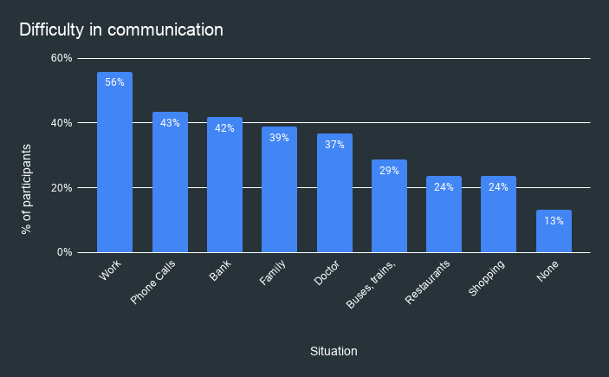

**1.5 SOFTWARE REQUIREMENT SPECIFICATION (SRS)**

### **Creating the dataset for sign language detection:**

It is fairly possible to get the dataset we need on the internet but in this project, we will be creating the dataset on our own.

We will be having a live feed from the video cam and every frame that detects a hand in the ROI (region of interest) created will be saved in a directory (here gesture directory) that contains two folders train and test, each containing 10 folders containing images captured using the create_gesture_data.py

### **Training CNN**

Now on the created data set we train a CNN.

First, we load the data using ImageDataGenerator of keras through which we can use the flow_from_directory function to load the train and test set data, and each of the names of the number folders will be the class names for the imgs loaded.

### **Predict the gesture**

In this, we create a bounding box for detecting the ROI and calculate the accumulated_avg as we did in creating the dataset. This is done for identifying any foreground object.

Now we find the max contour and if contour is detected that means a hand is detected so the threshold of the ROI is treated as a test image.

We load the previously saved model using keras.models.load_model and feed the threshold image of the ROI consisting of the hand as an input to the model for prediction.

Getting the necessary imports for model_for_gesture.py

**Workflow of proposed model**

The model takes video samples of gestures as input and provides a gesture label as output. It first extracts the frames from the video samples and saved them sequentially on the disk. The number of frames extracted from each video is recorded for the reference. Next, the sequence of contiguous images was fed to the 3D-CNN network. Finally, the output of the network is converted into the respective class label. demonstrates the work-flow of the proposed model.

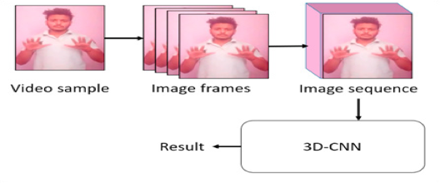

**1.6 FEASIBILITY STUDY**

As the name implies , a feasibility study is used to determine the viability of an idea, such as ensuring a project is legally and technically feasible as well as economically justifiable. It tells us whether a project is worth in the investment-in some cases, a project may not be feasible. Preliminary investigation examine project feasibility ,the likelihood the system will be useful to the organisation Feasibility is defined as the practical extent to which a project can be performed successfully. To evaluate feasibility, a feasibility study is performed, which determines whether the solution considered to accomplish the requirements is practical and workable in the software. Information such as resource availability, cost estimation for software development, benefits of the software to the organization after it is developed and cost to be incurred on its maintenance are considered during the feasibility study. The objective of the feasibility study is to establish the reasons for developing the software that is acceptable to users, adaptable to change and conformable to established standards. A feasibility study was an evaluation of a proposal designed to determine the difficulty in carrying out a designated task.

The main objective of the feasibility study is to test the Technical ,Operational And Economical Feasibility.

→Technical Feasibility:

The Technical Feasibility study basically centres on alternative for hardware, software and design approach to determine the functional aspects of system. In technical feasibility we study all technical issues regarding the proposed system. It is mainly concerned with the specifications of the equipment and the software, which successfully satisfies the end-user’s requirement.

The technical needs of the system may vary accordingly but include:

* The feasibility to produce outputs in a given time.
* Response time under certain conditions.
* Ability to process a certain volume of the transaction at a particular speed.
* Facility to communicate data.

→Operational Feasibility:

The system will be used if it is developed well them be resistance from users that undermine the possible application benefits .Operation Feasibility is measure of how people are able to work with system. This type of Feasibility demands if the system will work when developed and installed. Operational feasibility cover two aspect.one is technical performance and the other is acceptance by users. The system is operationally feasible as it is very interective and user friendly.

* User support

User will make hand gestures of letters from A- Z

It will help in the time saving and fast processing of word conversion in real time.

Economic Feasibility:

* The tools that will be used for this system are the latest one and thus the cost involved in tools, designing and developing the system will be a good investment for the organisation.

**1.7 DETAIL OF HARDWARE AND SOFTWARE USED**

**→Software used are:**

**Operating system:** Window 10 Home/Mac OS

**Platform :** Jupyter notebook

**Languages**

**Python :-**

1. For Building AI model.

**Libraries:**

1. Keras
2. Numpy
3. Tensorflow
4. Pandas
5. matplotlib

**→Hardware used are:**

* Intel core i5 8 generation/M1 processor

* 1 TB Hard Disk/256 GB SSD

* 8 GB DDR4 RAM

* Laptop & Desktop

**2. System Analysis and Design:-**

**2.1 DETAILED LIFE CYCLE OF THE PROJECT**

In this Project we used Incremental Modal for developing our project.

The incremental build model is a method of software development where the model is designed, implemented and tested incrementally (a little more is added each time) until the product is finished. It involves both development and maintenance. The product is defined as finished when it satisfies all of its requirements. This model combines the elements of the waterfall model with the iterative philosophy of prototyping.

The product is decomposed into a number of components, each of which are designed and built separately (termed as builds). Each component is delivered to the client when it is complete. This allows partial utilization of product and avoids a long development time. It also creates a large initial capital outlay with the subsequent long wait avoided. This model of development also helps ease the traumatic effect of introducing completely new system all at once.

There are some problems with this model. One is that each new build must be integrated with previous builds and any existing systems.

The task of decomposing product into builds not trivial either. If there are too few builds and each build degenerates this turns into Build-And-Fix model. However if there are too many builds then there is little added utility from each build.

The various phases of incremental model are as follows:

1. Requirement analysis: In the first phase of the incremental model, the product analysis expertise identifies the requirements. And the system functional requirements are understood by the requirement analysis team. To develop the software under the incremental model, this phase performs a crucial role.

2. Design & Development: In this phase of the Incremental model of SDLC, the design of the system functionality and the development method are finished with success. When software develops new practicality, the incremental model uses style and development phase.

3. Testing: In the incremental model, the testing phase checks the performance of each existing function as well as additional functionality. In the testing phase, the various methods are used to test the behaviour of each task.

4. Implementation: Implementation phase enables the coding phase of the development system. It involves the final coding that design in the designing and development phase and tests the functionality in the testing phase. After completion of this phase, the number of the product working is enhanced and upgraded up to the final system product.

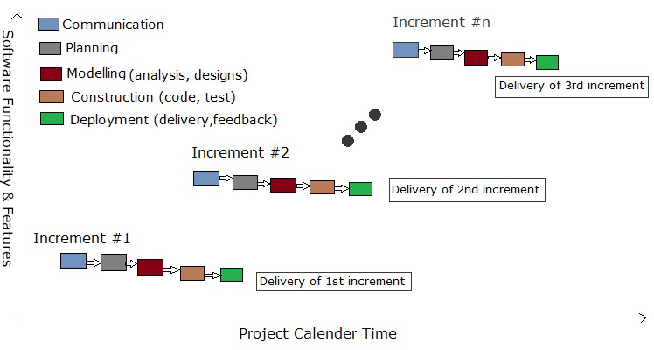[Courtesy Google]

**Advantage of Incremental Modal:-**

* Generates working software quickly and early during the software life cycle.
* More flexible – less costly to change scope and requirements.
* Easier to test and debug during a smaller iteration.
* Easier to manage risk because risky pieces are identified and handled during its iteration.

**2.2 DATA FLOW DIAGARM:**

DFD represents the flows of data between different processes in a business. It is a graphical technique that depicts information flow and the transform that are applied as data move from input to output. It provides a simple, intuitive method for describing business processes without focusing on the details of computer system. DFDs are attractive because they provide what users do rather than what computer do.

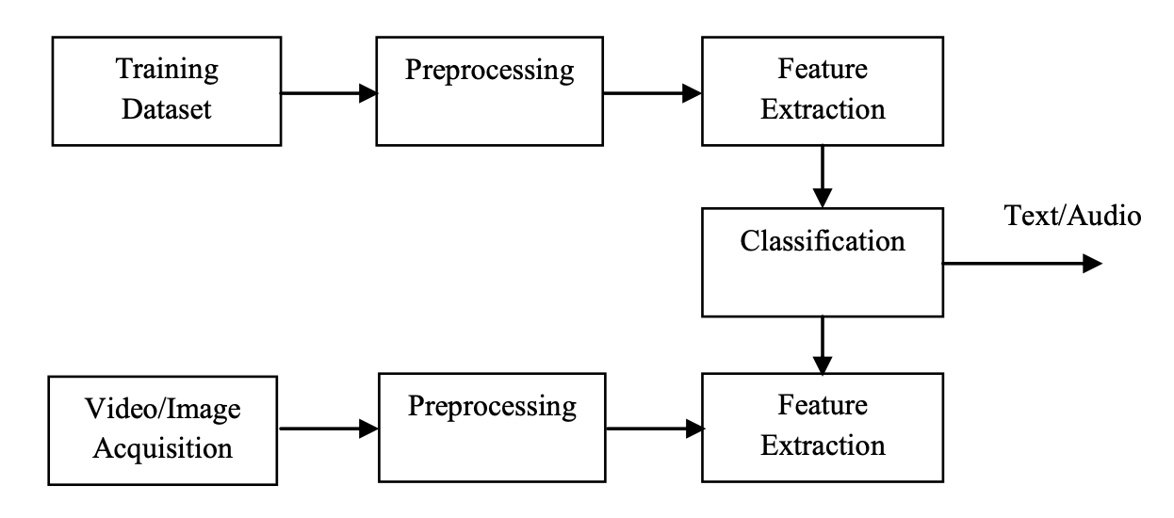

**2.3 USE CASE DIAGRAM**

A use case diagram at its simplest is a representation of a user’s interaction with the system and depicting the specification of a use case. It can portray the different types of users of a system and the various ways that they interact with the system. This type of diagram is typically used in conjuction with the textual use case and will often be accompanied by other types of diagram as well.

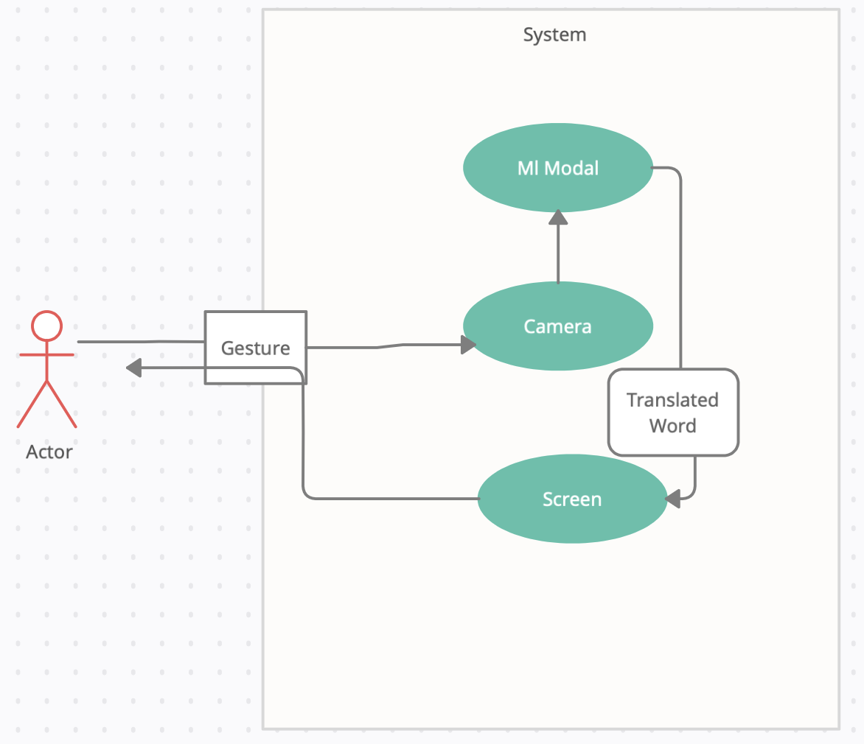

**2.4 ACTIVITY DIAGRAM:**

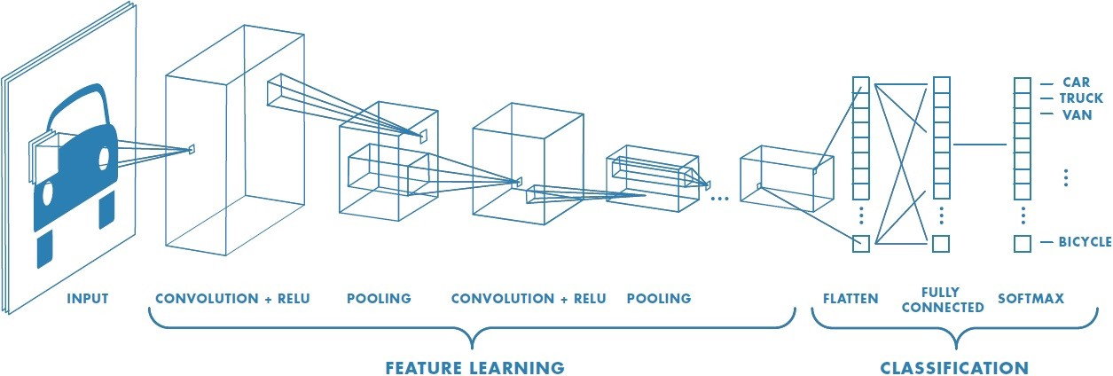

**2.5 SEQUENCE DIAGRAM:**

A sequence diagram simply depicts interaction between objects in **a sequential** order i.e. the order in which these interactions take place. We can also use the terms event diagrams or event scenarios to refer to a sequence diagram.Sequence diagrams describe how and in what order the objects in a system function.

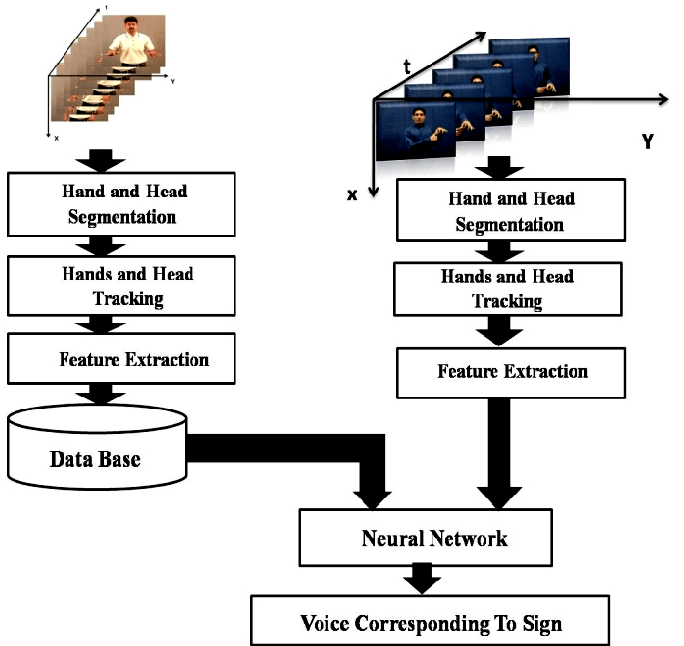

**TEXT Corresponding to Sign**

**2.6 COMPONENT DIAGRAM:**

Mainly the component diagram consists of database, User Interface and component and shows the relationship between them.

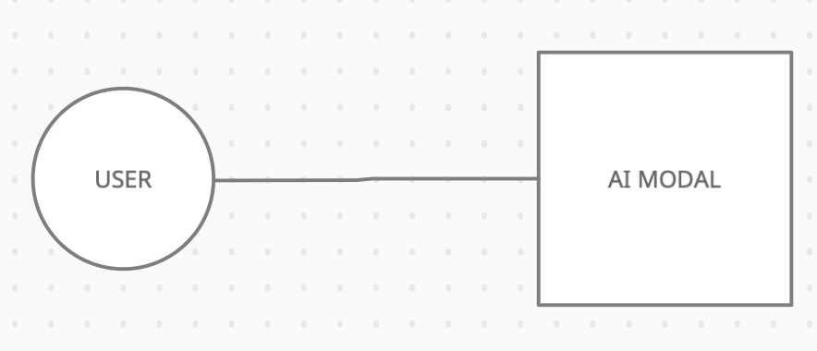

**2.7 ARCHITECTURE DESIGN:**

The software needs the architectural design to represents the design of software. IEEE defines architectural design as “the process of defining a collection of hardware and software components and their interfaces to establish the framework for the development of a computer system.” The software that is built for computer-based systems can exhibit one of these many architectural styles.

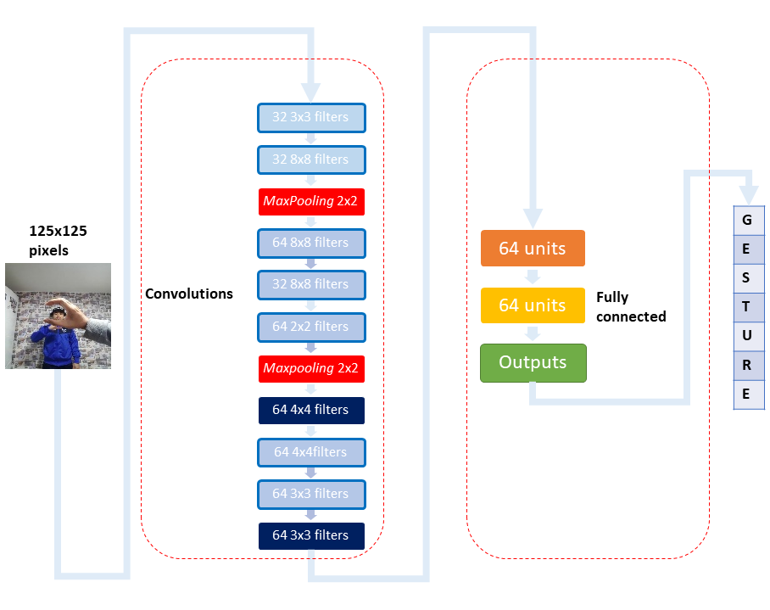

**3. SYSTEM PLANNING:-**

**3.1 GANTT CHART:**

A Gantt chart is a horizontal bar chart developed as a production control tool in 1917 by Henry L. Gantt. It provides a graphical representation of a scheduled that helped to plan, coordinates and track specific task on a project. is one of the most popular and useful ways of showing activities (tasks or events) displayed against time. On the left of the chart is a list of the activities and along the top is a suitable time scale. Each activity is represented by a bar; the position and length of the bar reflects the start date, duration and end date of the activity. This allows you to see at a glance:

* What the various activities are.
* Where activities overlap with other activities, and by how much.
* How long each activity is scheduled to last.
* When each activity begins and ends.
* The start and end date of the whole project.

|  |  |  |  |  |  |  |  |  |  |  |
| --- | --- | --- | --- | --- | --- | --- | --- | --- | --- | --- |
| Task | Start Date | End Date | Aug-2021 | Sept-2021 | Oct-2021 | Nov-2021 | Dec-2022 | Jan-2022 | Feb-2022 | Mar-2022 |
| Initiation | 01-08-21 | 06-08-21 |  |  |  |  |  |  |  |  |
| Planning | 01-08-21 | 25-09-21 |  |  |  |  |  |  |  |  |
| Training for Android | 10-01-22 | 30-01-22 |  |  |  |  |  |  |  |  |
| Software Configuration | 1-01-22 | 2-02-22 |  |  |  |  |  |  |  |  |
| Analysis | 02-09-19 | 12-09-19 |  |  |  |  |  |  |  |  |
| Preparation of SRS | 18-09-21 | 06-10-21 |  |  |  |  |  |  |  |  |
| Design | 15-10-21 | 30-10-21 |  |  |  |  |  |  |  |  |
| Coding | 01-12-22 | 01-03-22 |  |  |  |  |  |  |  |  |
| Testing | 02-03-22 | 14-03-22 |  |  |  |  |  |  |  |  |
| Documentation | 01-10-21 | 15-03-22 |  |  |  |  |  |  |  |  |

|  |  |
| --- | --- |
|  | Expected Value |
|  | Actual Value |

**4. Cost and Benefit analysis**

**Effort Estimation Using COCOMO Model:**

For any set of specifications. It's critical to know how much it'll cost to develop the application software to meet the stated criteria, as well as how long it'll take; these estimates are required before development begins. The main purpose of cost and schedule estimation is to allow the client or developer to undertake a cost-benefit analysis as well as to monitor and control the project.

The project has been developed considering the cocomo (constructive cost model) model which computes software development effort as a function of program size and set of “cost driver” that include product , hardware , personnel and project attribute. Efforts is calculated in terms of person-month.

**Steps of analysis:**

**Step🡪1.**

Obtain an initial estimate of development effort as follows:

**Ei=a*(KSLOC) b**

Where a & b are constants which are determined depending on the type of project. KSLOC is thousand single lines of code

**Step🡪2.**

Determine a set of 15 multiplying factors from different attributes of the product which are:-

**Product attributes:**

Required reliability, product complexity, Size of application database.

**Computer attributes**:

Execution time constraints, main storage constraints, virtual machine volatility, computer term around time.

**Personnel attributes:**

Analyst capability, application experience, programmer capability, virtual machine experience, programming language experience.

**Product attributes:**

Modern programming practices, use of the software tools, required development schedule.

**Effort adjustment factor(EAF)**

Final effort estimate is calculated by multiplying the initial estimate with EAF

**E=EAF*ei(person-month)**

Following is a basic COCOMO model of the system based on Organic Mode.

**🡪 EAF calculation:-**

|  |  |  |
| --- | --- | --- |
| **Product Attributes** | **Rating** | **Rating** |
| Requires Software Reliability | High | 1.15 |
| Complexity Of The Product | High | 1.00 |
| Size of application database | Normal | 1.00 |
|  |  |  |
| **Hardware Attributes** |  |  |
| Run Time Performance Constrains | High | 1.11 |
| Memory Constraints | Normal | 1.00 |
| Volatility Of The Virtual Machine Environment | Low | 0.87 |
|  |  |  |
| **Personnel Attributes** |  |  |
| Analyst Capability | High | 0.86 |
| Software Engineer Capability | High | 0.86 |
| Application Experience | High | 0.91 |
| Programming Language Experience | High | 0.95 |
|  |  |  |
| **Product Attributes** |  |  |
| Use Of Software Tools | Normal | 1.00 |
| Application Of Software engineering Methods | High | 0.91 |
| Required Development Schedule | Normal | 1.00 |

**E=Ai(KLOC)(Bi) /.EAF**

Where E is the effort applied in person-month, KLOC is the estimated number of thousand of delivered lines of code for the project and EAF is the factor calculated above **Ai=3.2** and **Bi=1.05**

**EAF= 1.15*1.00*1.00*1.11*1.00*0.87*0.86*0.86*0.91*0.95*1.00*0.91*1.00**

**= 0.646164901**

**Estimation of Development Cost :**

Total time required to develop this project : 8 Months.

As we are students & we are developing an academic project, so we cannot calculate actual cost of this product, because we have done this project 2 days/3 days per weeks(3days * 4weeks * 8months =96 days) approximate 3 month time has we devoted to developed this product.

**5.SYSTEM TESTING.**

**5.1Methodology Adopted For Testing :**

Testing is a process of executing a program with the intent of finding errors.

A good test case is one that has a high probability of finding an as yet undiscovered error.

A successful test is one that uncovers an as yet undiscovered error. If testing is conducted successfully it will uncover error in the software and testing demonstrates that software functions appear to be working according to specification, that behavior and performance requirement appear to have been met. In addition, data collected as testing provide good indication of software reliability and some indication of software quality whole. But testing cannot show the absence of errors and defects, it can only shows that errors and defects are present.

**5.2 Testing Principles :**

* All the tests should be traceable to customer requirements. Test should be planned long before testing begins.
* Testing should begin in small scale and progress towards large scale.
* Exhaustive testing is not possible.
* Testing should be conducted by independent third party.

**5.3Testing Methods :**

Testing must have designed with the highest likelihood to find possible errors in the system to avoid major problems before the system goes live.

There are two methods to design the test case :

1. White Box Testing
2. Black Box Testing

**5.4 White Box Testing :**

Structure-based testing technique is also known as ‘white-box’ or ‘glass-box’ testing technique because here the testers require knowledge of how the software is implemented, how it works.

In white-box testing the tester is concentrating on how the software does it. For example, a structural technique may be concerned with exercising loops in the software.

Different test cases may be derived to exercise the loop once, twice, and many times. This may be done regardless of the functionality of the software.

Structure-based techniques can also be used at all levels of testing. Developers use structure-based techniques in component testing and component integration testing, especially where there is good tool support for code coverage.

Structure-based techniques are also used in system and acceptance testing, but the structures are different. For example, the coverage of menu options or major business transactions could be the structural element in system or acceptance testing.

**5.5 Black Box Testing :**

Specification-based testing technique is also known as ‘black-box’ or input/output driven testing techniques because they view the software as a black-box with inputs and outputs.

The testers have no knowledge of how the system or component is structured inside the box. In black-box testing the tester is concentrating on what the software does, not how it does it.

The definition mentions both functional and non-functional testing. Functional testing is concerned with what the system does its features or functions. Non-functional testing is concerned with examining how well the system does.

Non-functional testing like performance, usability, portability, maintainability, etc.

     This testing was also done so as to find errors such as:

1. Initialization and termination errors
2. Behavior and performance errors
3. Incorrect or missing functions
4. Interface errors
5. Errors in data structures and external database access
6. Performance errors.

The other software testing techniques were used in order to uncover errors in the system are:

1. GUI Testing
2. System Testing

**5.6 Types of Testing :**

**1. Alpha Testing**

Alpha testing is one of the most common software testing strategy used in software development. It’s specially used by product development organizations.

This test takes place at the developer’s site. Developers observe the users and note problems.

Alpha testing is testing of an application when development is about to complete. Minor design changes can still be made as a result of alpha testing.

Alpha testing is typically performed by a group that is independent of the design team, but still within the company, e.g. in-house software test engineers, or software QA engineers.

Alpha testing is final testing before the software is released to the general public. It has two phases:

In the first phase of alpha testing, the software is tested by in-house developers. They use either debugger software, or hardware-assisted debuggers. The goal is to catch bugs quickly.

In the second phase of alpha testing, the software is handed over to the software QA staff, for additional testing in an environment that is similar to the intended use.

Alpha testing is simulated or actual operational testing by potential users/customers or an independent test team at the developers’ site. Alpha testing is often employed for off-the-shelf software as a form of internal acceptance testing, before the software goes to beta testing.

1. **Beta Testing**

It is also known as field testing. It takes place at customer’s site. It sends the system to users who install it and use it under real-world working conditions.

A beta test is the second phase of software testing in which a sampling of the intended audience tries the product out. (Beta is the second letter of the Greek alphabet.) Originally, the term alpha test meant the first phase of testing in a software development process. The first phase includes unit testing, component testing, and system testing. Beta testing can be considered “pre-release testing. The goal of beta testing is to place your application in the hands of real users outside of your own engineering team to discover any flaws or issues from the user’s perspective that you would not want to have in your final, released version of the application.

1. **Performance Testing**

Performance testing is in general testing performed to determine how a system performs in terms of responsiveness and stability under a particular workload.

It can also serve to investigate, measure, validate or verify other quality attributes of the system, such as scalability, reliability and resource usage. It is  a type of non-functional testing.

Performance testing is testing that is performed, to determine how fast some aspect of a system performs under a particular workload.

It can serve different purposes like it can demonstrate that the system meets performance criteria. It can compare two systems to find which performs better. Or it can measure what part of the system or workload causes the system to perform badly. This process can involve quantitative tests done in a lab, such as measuring the response time or the number of MIPS (millions of instructions per second) a which a system functions

1. **Recovery Testing**

It is a type of [non-functional testing](http://istqbexamcertification.com/what-is-non-functional-testing-testing-of-software-product-characteristics/). Recovery testing is done in order to check how fast and better the application can recover after it has gone through any type of crash or hardware failure etc. Recovery testing is the forced [failure](http://istqbexamcertification.com/what-is-a-failure-in-software-testing/) of the software in a variety of ways to verify that recovery is properly performed. For example: When an application is receiving data from a network, unplug the connecting cable. After some time, plug the cable back in and analyse  the application’s ability to continue receiving data from the point at which the network connection was broken. Example: Restart the system while a browser has a definite number of sessions and check whether the browser is able to recover all of them or not.

**5.11 Software Testing Strategies Adopted :**

**5.12 Unit testing**

A unit is the smallest testable part of an application like functions, classes, procedures, interfaces. Unit testing is a method by which individual units of source code are tested to determine if they are fit for use.

Unit tests are basically written and executed by software developers to make sure that code meets its design and requirements and behaves as expected.

The goal of unit testing is to segregate each part of the program and test that the individual parts are working correctly.

This means that for any function or procedure when a set of inputs are given then it should return the proper values. It should handle the failures gracefully during the course of execution when any invalid input is given.

A unit test provides a written contract that the piece of code must assure. Hence it has several benefits.

**5.13 Integration testing**

Integration testing tests integration or interfaces between components, interactions to different parts of the system such as an operating system, file system and hardware or interfaces between systems.

Also after integrating two different components together we do the integration testing. As displayed in the image below when two different modules ‘Module A’ and ‘Module B’ are integrated then the integration testing is done.

Integration testing is done by a specific integration tester or test team.

Integration testing follows two approach known as ‘Top Down’ approach and ‘Bottom Up’ approach.

**5.14 System testing**

In system testing the behaviour of whole system/product is tested as defined by the scope of the development project or product.

It may include tests based on risks and/or requirement specifications, business process, use cases, or other high level descriptions of system behaviour, interactions with the operating systems, and system resources.

System testing is most often the final test to verify that the system to be delivered meets the specification and its purpose.

System testing is carried out by specialists testers or independent testers.

System testing should investigate both functional and non-functional requirements of the testing.

**5.15 Regression testing**

During confirmation testing the defect got fixed and that part of the application started working as intended. But there might be a possibility that the fix may have introduced or uncovered a different defect elsewhere in the software. T

he way to detect these ‘unexpected side-effects’ of fixes is to do regression testing. The purpose of a regression testing is to verify that modifications in the software or the environment have not caused any unintended adverse side effects and that the system still meets its requirements. Regression testing are mostly automated because in order to fix the defect the same test is carried out again and again and it will be very tedious to do it manually. Regression tests are executed whenever the software changes, either as a result of fixes or new or changed functionality.

**6.IMPLEMENTATION:-**

**🡪SCREENSHOTS: -**

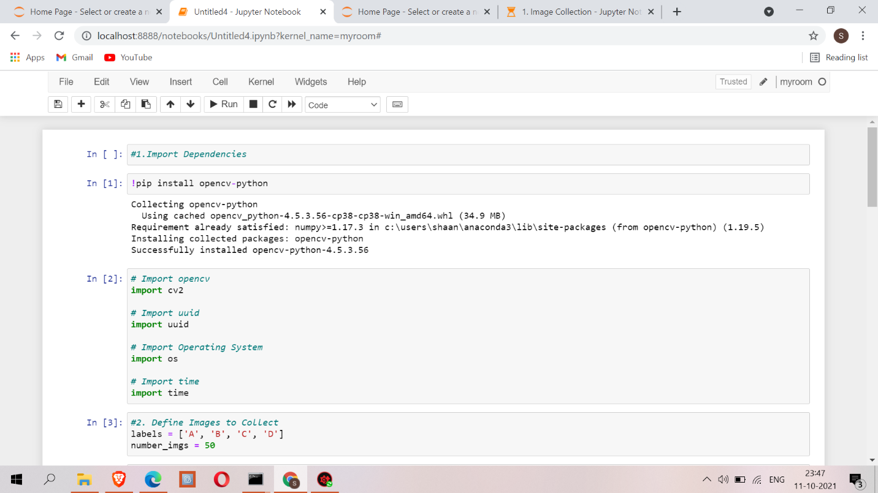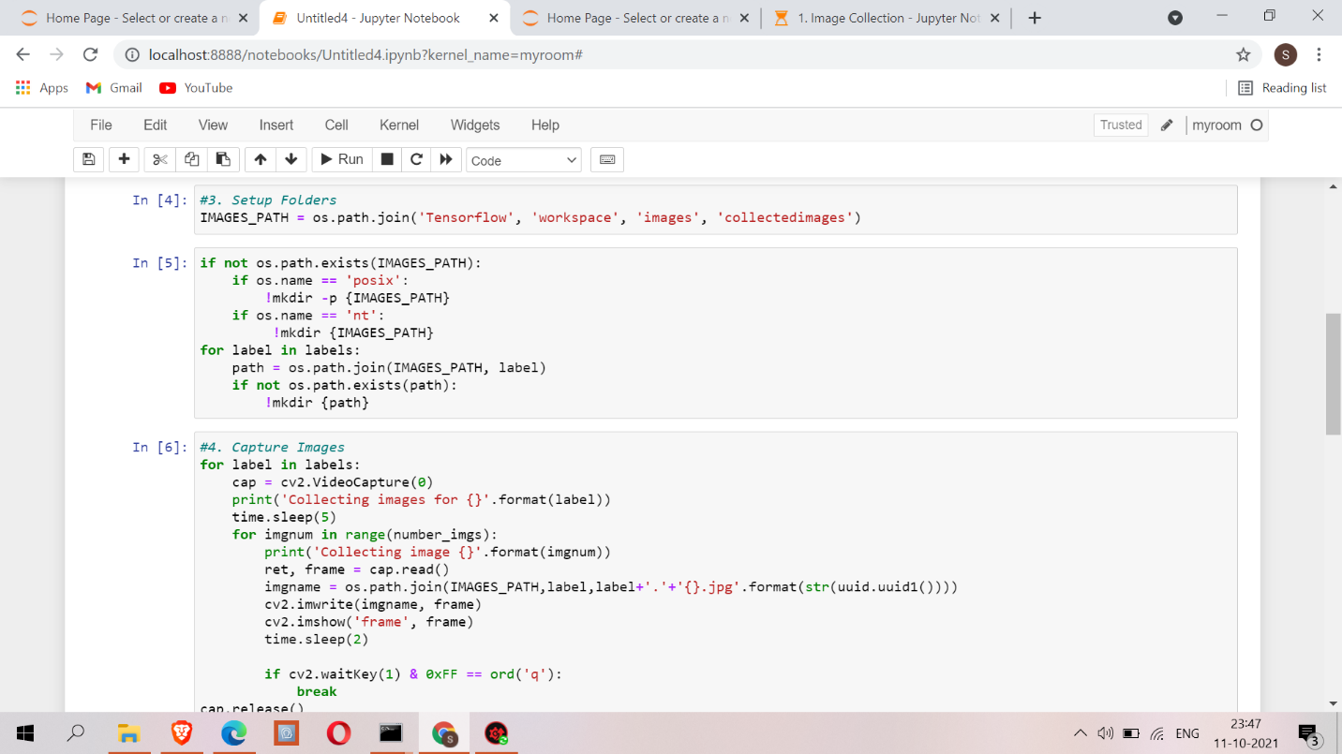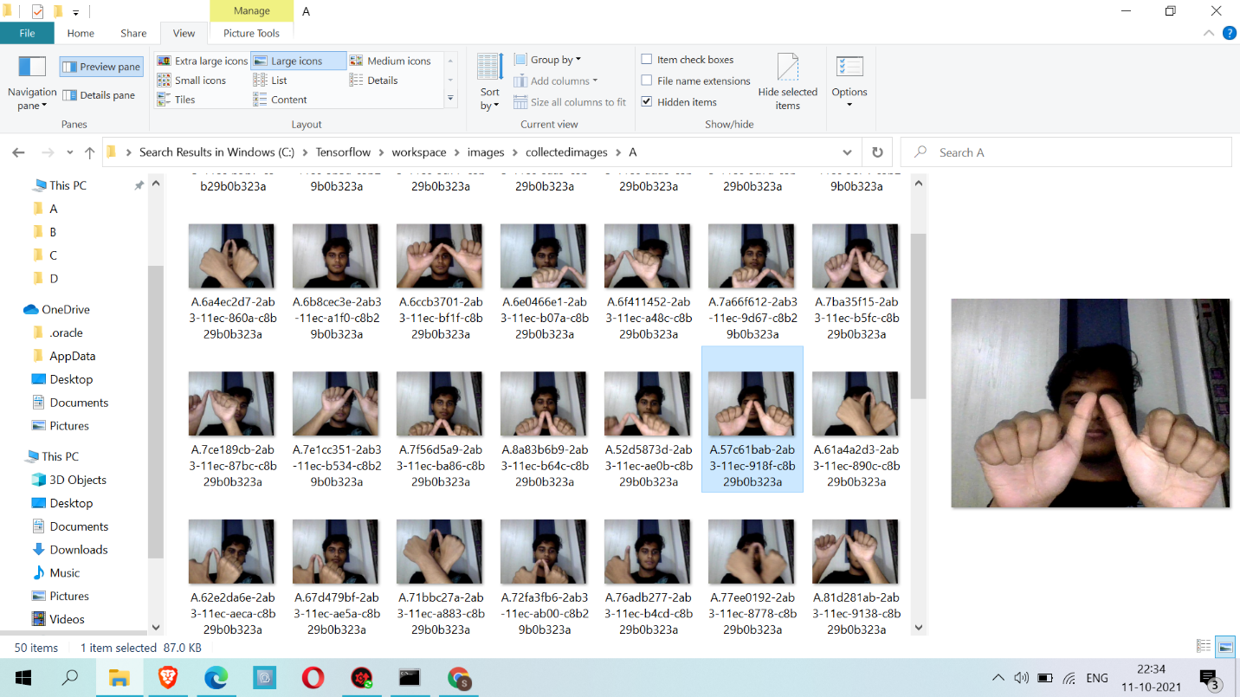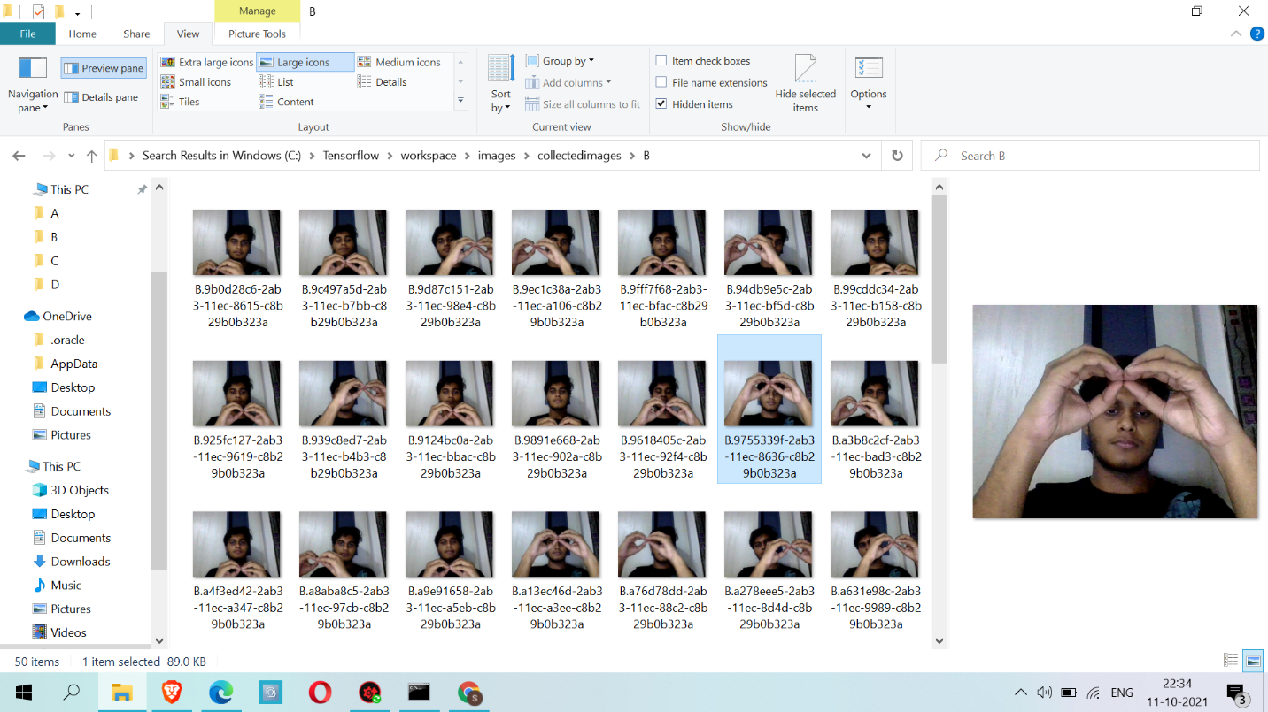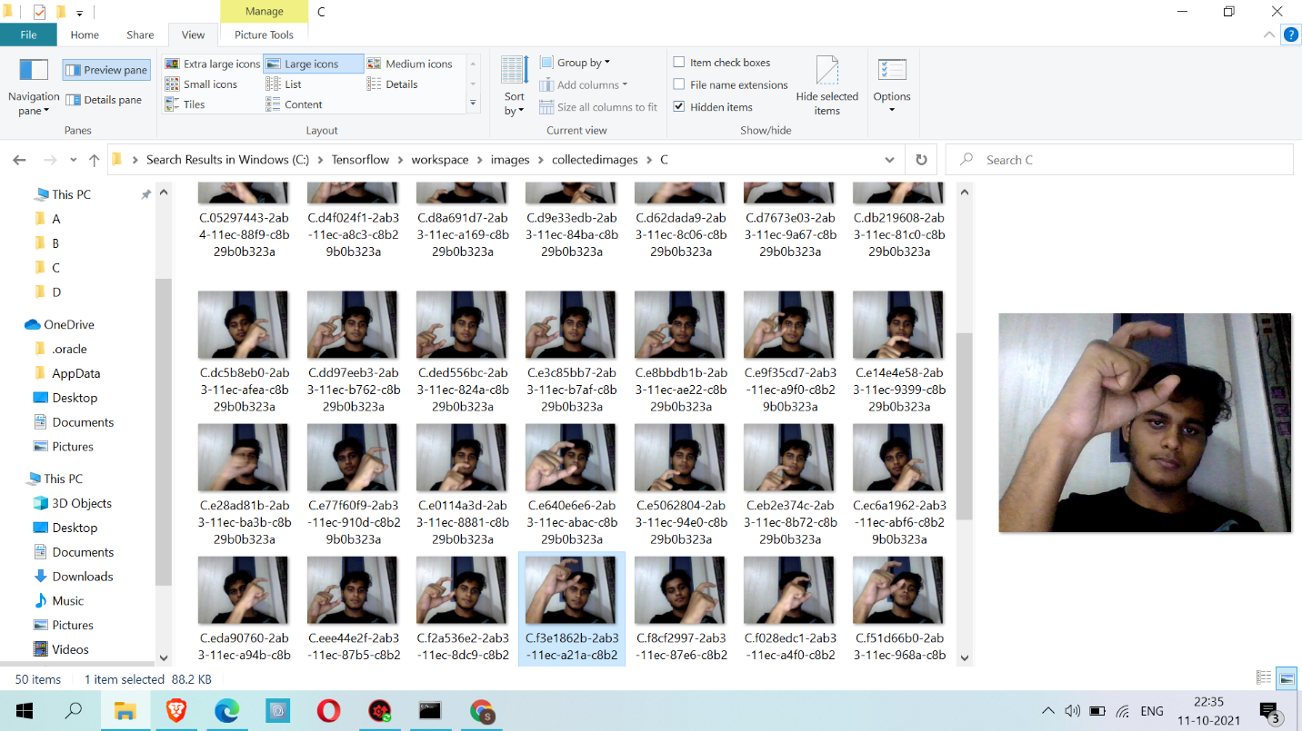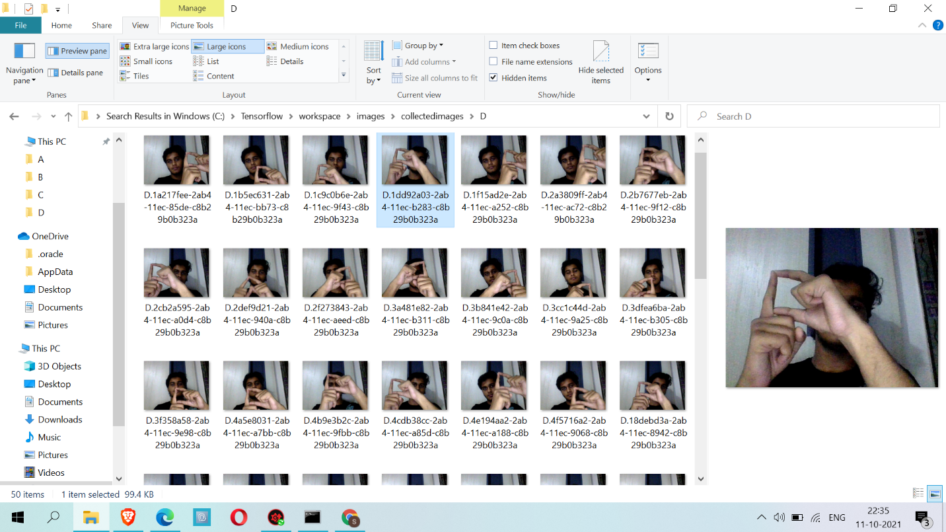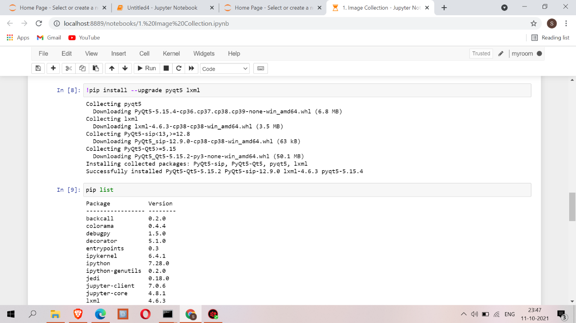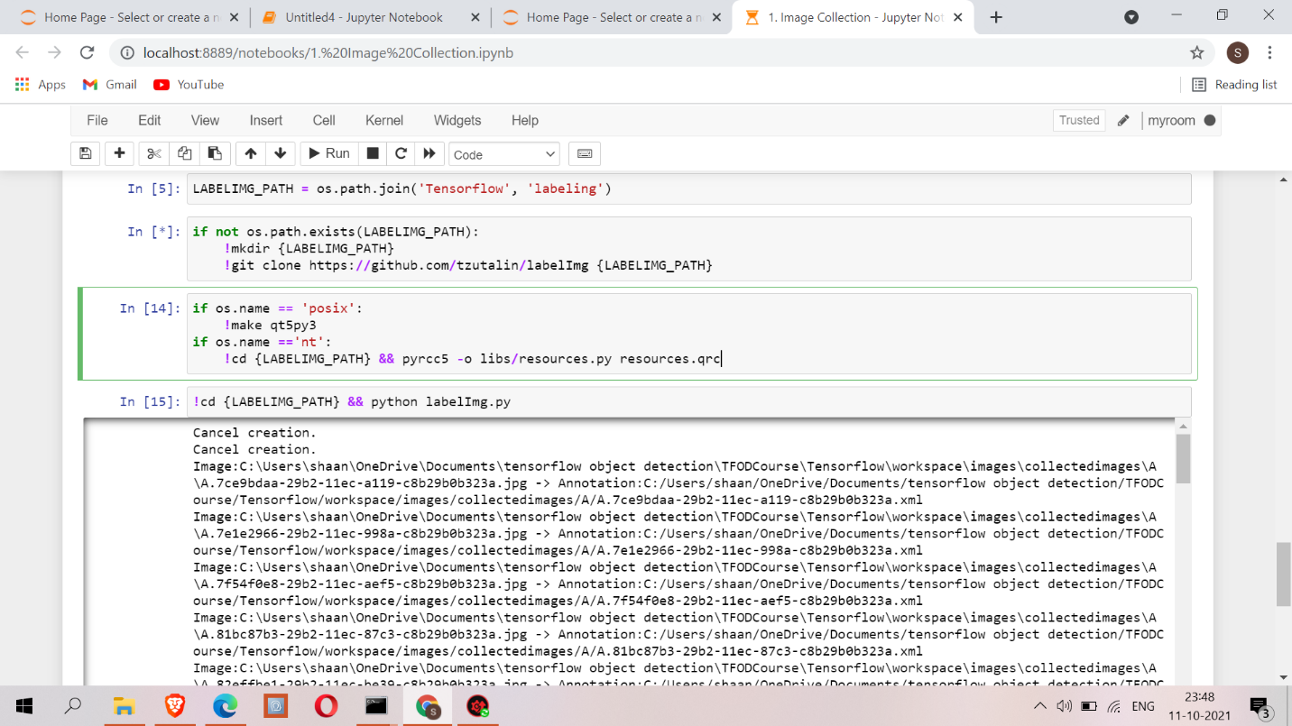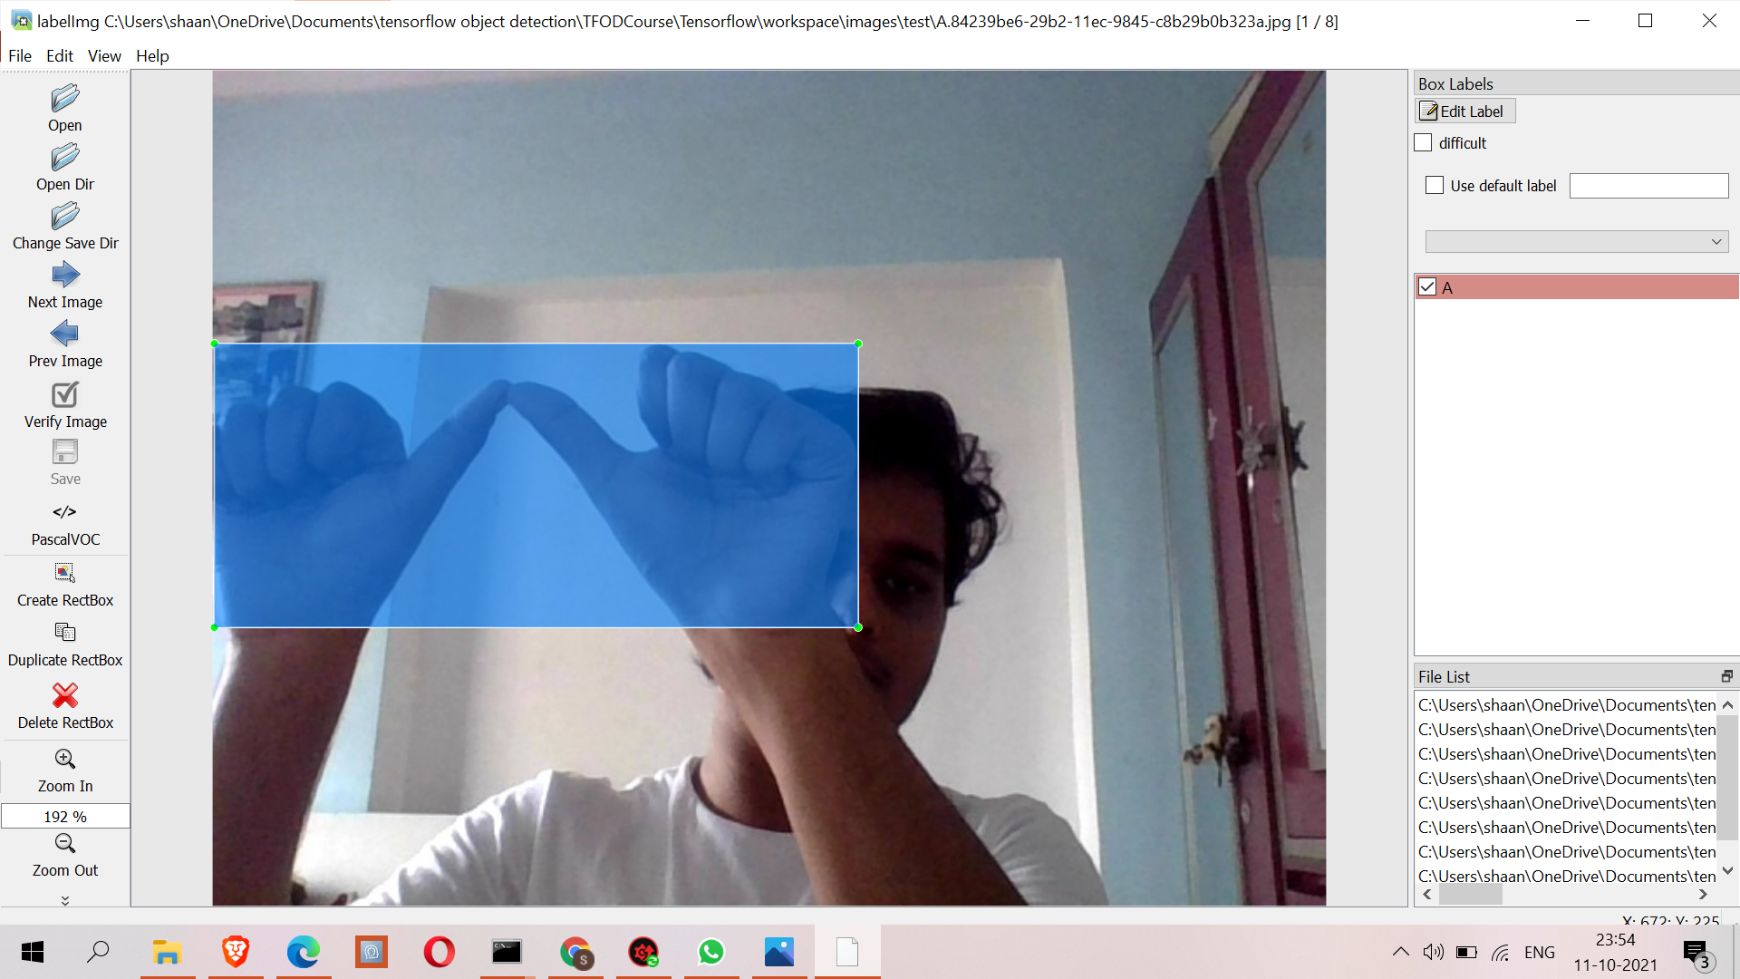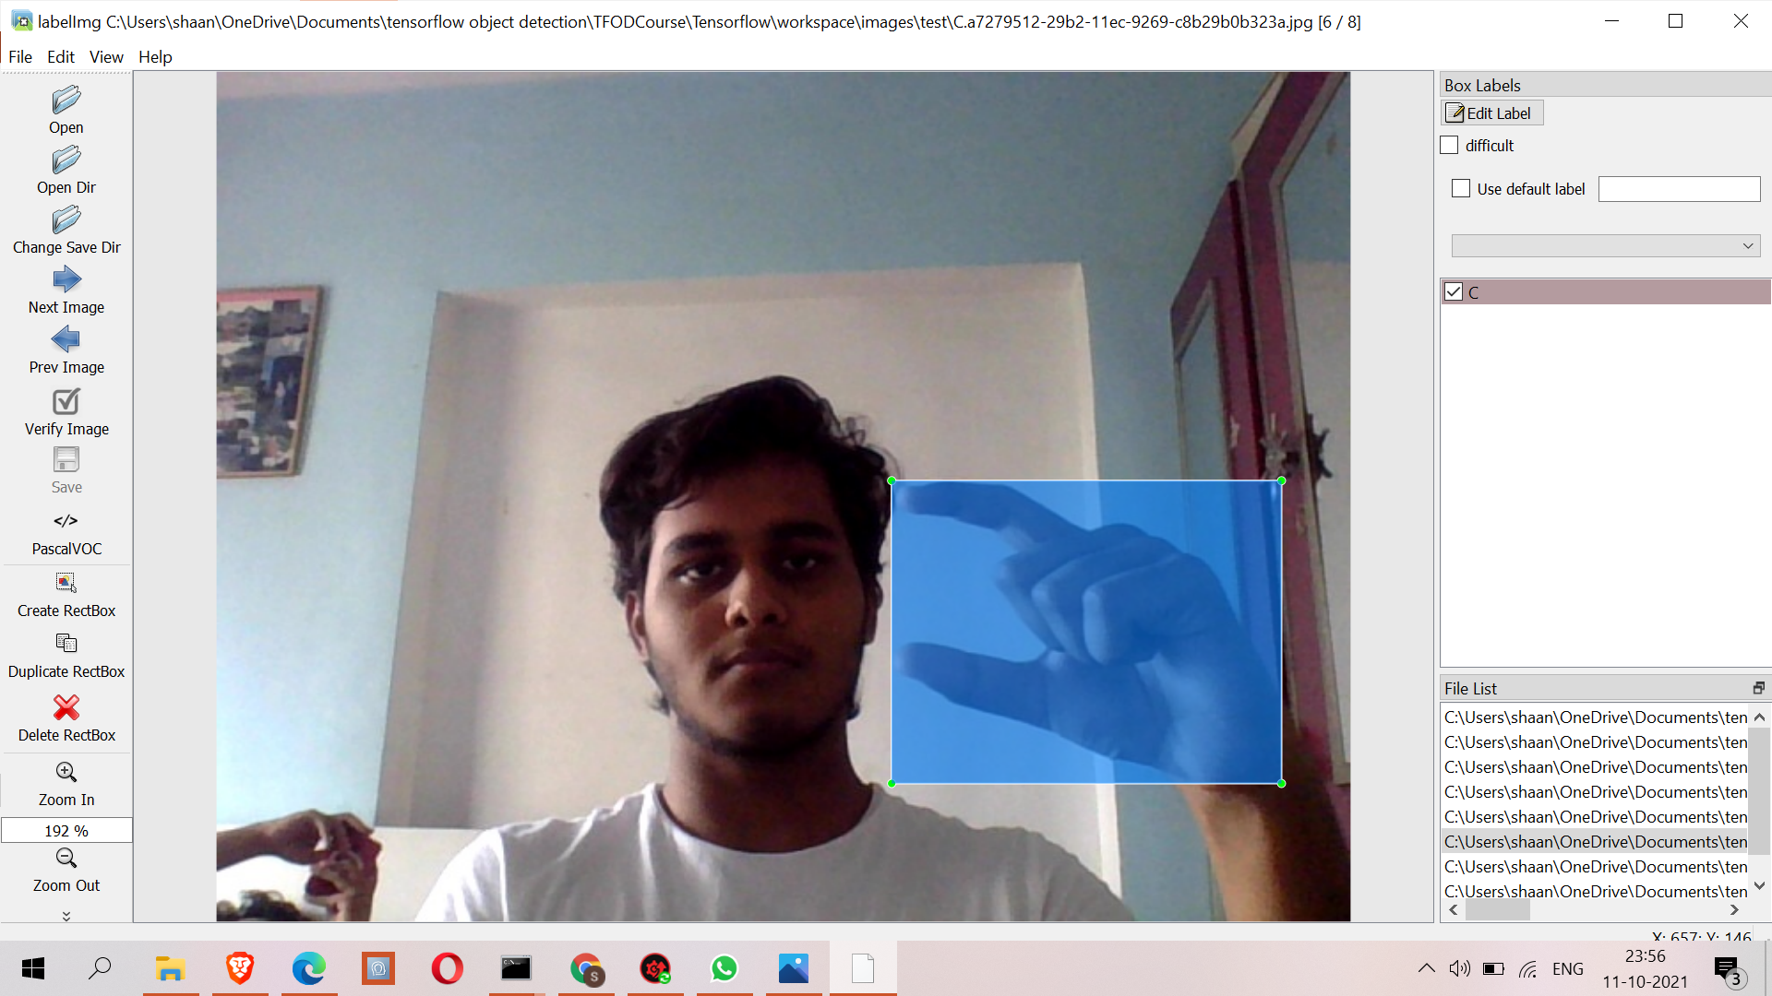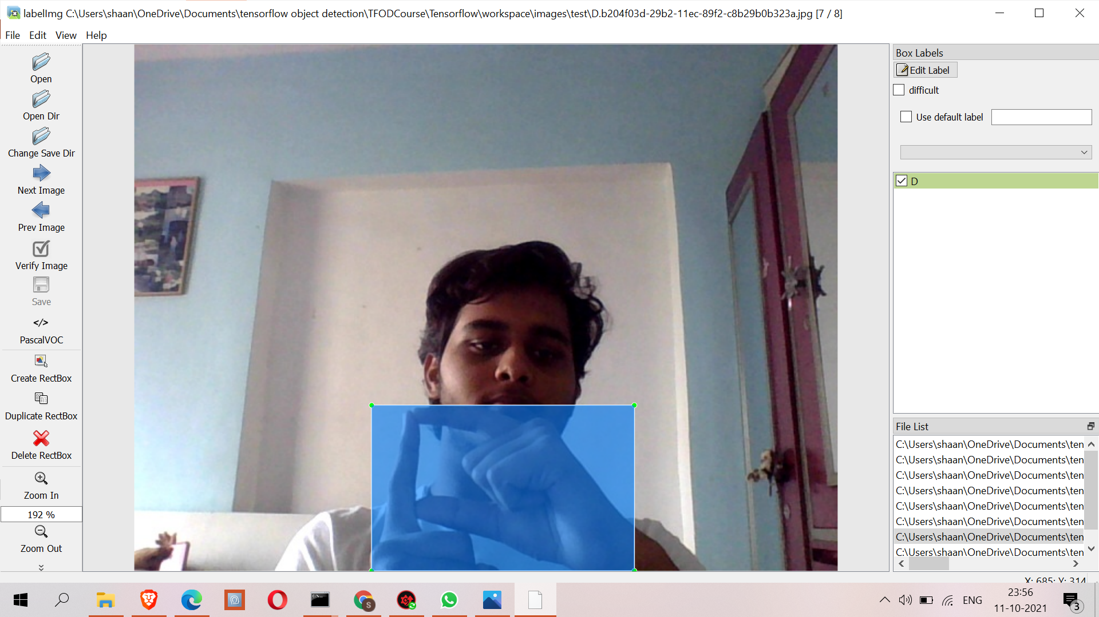

**8. FUTURE WORK**

Software technology advancements are occurring at a rapid pace. This has compelled designers and developers to seek out new approaches to design and development. To deal with this situation, the modules in a package should be updated at any time. The modules included in this package can be improved further. As an example:

1. We integrate this project with Django
2. Will be making a full pleged video chat application that has the ability to generate sign or gesture to text in real time
3. Addition a functionality where user can train their own gesture by capturing the image and typing what that image means
4. If possible we will be deploying this application on any cloud such as Heroku or Aws or Hostlinger

**9.REFERENCES**

1) Noor Adnan Ibraheem, RafiqulZaman Khan, 2012, Survey on Various Gesture Recognition Technologies and Techniques, International Journal of Computer Applications, Volume 50, No. 7

2) P.V.V Kishore, P. Rajesh Kumar, E. Kiran Kumar & S.R.C.Kishore, 2011, Video Audio Interface for Recognizing Gestures of Indian Sign Language, International Journal of Image Processing (IJIP), Volume 5, Issue 4, 2011 pp. 479-503

3) P.V.V.Kishore, P.Rajesh Kumar, 2012, A Model For Real Time Sign Language Recognition System, International Journal of Advanced Research in Computer Science and Software Engineering Volume 2, Issue 6, June 2012 pp. 30-35